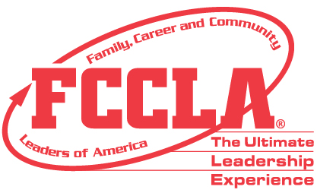

FCCLA Planning Process
Summary Page Template

IDENTIFY CONCERNS

Our concern for this project was that there was a lack of knowledge and communication among chapter members, high school student, and the community to find general and specific information about the Boonville FCCLA Chapter. We wanted to have a central place that was easy to access for everybody in our community. We also wanted to use our website as a way to educate and promote FCCLA.

SET A GOAL

Our goal was to create an informational and easy-to-use website for chapter members, high school students, and the community to find information about Boonville FCCLA. We wanted our members and community members to be able to easily search for our website and have it answer their questions in the best way possible.

FORM A PLAN

Who: Angelina and Ivory will be the creators of the website. The website will be of use to, the Boonville High School FCCLA members, potential members, parents, and the community.
What: An informative website, for the local FCCLA chapter.
When: Both Angelina and Ivory started on this project in late August, we published the website in late January.
Where: We worked on it at school, home, and Boonville High School
Why: This project was done because of the lack of knowledge our community has of FCCLA and the fact there wasn’t a convenient location for our information for our members.
How: We used a free website maker called, Weebly, and adapted it to fit our liking.

ACT
We started our project by just sitting down for a few hours before Christmas break and looking and playing around with the website maker called Weebly. We wanted to make sure we fully knew how to create our website with all the tools the website had to offer. This process actually took longer than we thought it would and we were discovering new things we could do even up to the finishing of the website. We then proceeded to break down the rubric and began to piece together the important parts that were required. Next, we added some topics that weren’t required but we wanted to mention such as community service and conferences. Between Ivory and I’s busy schedules, the whole process took about two months to finally accomplish finishing the website.

FOLLOW UP

If we could change anything we would change, not waiting until the last week to finish all the small details and present it to our chapter. If we would have presented it to our chapter earlier than we would could have changed the details they told us about sooner. We would have also planned more time to sit down with our computer teacher at our high school and get her opinion and tips on how to make our website more successful. We would also get community members feedback and see how they feel about it and to see if it was successful in educating them.

